to the

Consultation on immigration settings for international students

4 July 2018
- Introduction
The PPTA is the union representing around 17,500 teachers in state secondary, area, manual training and intermediate schools, as well as tutors in community education institutions and principals in secondary and area schools. PPTA represents the professional and industrial interests of its members, including those working in alternative education centres and activity centres.

- PPTA would like to submit on one aspect of the consultation on immigration settings for international students.

- Our concern in this area relates to the issue of teacher supply into the secondary teaching workforce.

- Qualification requirements for secondary teachers

4.1 The standard qualification for students completing initial teacher education (ITE) for secondary teaching is through a graduate diploma course. This is a Level 7 sub-degree qualification.

  - All the universities (other than Otago University) and other institutions offer initial teacher education at this level, and the majority of initial teacher education graduates come through this path – the alternative is the Masters level initial teacher education course that some providers now offer.

- Current supply issues

  - Secondary teacher supply is currently in a state of crisis. The number of students graduating from initial teacher education (secondary, programmes) has dropped significantly in recent years, as the graph below, (data from Education Counts) demonstrates.

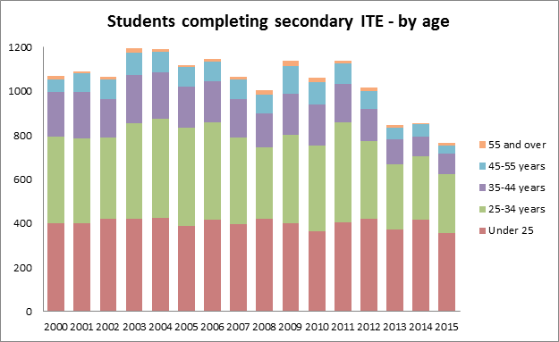

  - In 2016 the number of graduates continued to decline, with 715 completing that year.
With current loss rates from the workforce of around 8% per year, the number required to fill spaces left by teachers leaving is around 1,900. The gap between the two is currently partially met by teachers coming back into the profession from the ‘flexible pool’, and experienced teachers coming from overseas on work visas. However, in many instances, the gap is leading to employers in schools having to make compromises in their appointments, cutting subject options, or combining classes, all of which have negative implications for learners.

- International students studying secondary ITE

6.1 Data from Education Counts shows the figures for secondary initial teacher education graduates who are international students for the years between 2008 and 2015.

Number of students completing initial teacher education qualifications by sector
Domestic/international | Sector | 2008 | 2009 | 2010 | 2011 | 2012 | 2013 | 2014 | 2015
Domestic | ECE | 1,840 | 1,795 | 2,000 | 2,285 | 2,475 | 2,315 | 1,885 | 1,590
 | Primary | 1,740 | 1,905 | 1,670 | 2,090 | 2,060 | 1,925 | 1,895 | 1,645
 | Secondary | 1,000 | 1,135 | 1,065 | 1,145 | 1,020 | 845 | 860 | 760
 | Unknown | 105 | 70 | 65 | 55 | 80 | 40 | 35 | 45
 | Total | 4,685 | 4,905 | 4,800 | 5,570 | 5,630 | 5,125 | 4,670 | 4,045
International | ECE | 30 | 75 | 90 | 140 | 180 | 190 | 110 | 140
 | Primary | 45 | 65 | 35 | 60 | 20 | 20 | 20 | 20
 | Secondary | 80 | 65 | 65 | 60 | 35 | 30 | 30 | 15
 | Unknown | 0 | 0 | 0 | 0 | 5 | 0 | 5 | 5
 | Total | 155 | 205 | 190 | 265 | 240 | 240 | 160 | 175
Total | ECE | 1,870 | 1,865 | 2,090 | 2,420 | 2,655 | 2,505 | 1,995 | 1,730
 | Primary | 1,785 | 1,970 | 1,705 | 2,155 | 2,080 | 1,945 | 1,915 | 1,665
 | Secondary | 1,080 | 1,200 | 1,130 | 1,205 | 1,055 | 875 | 885 | 775
 | Unknown | 105 | 70 | 70 | 55 | 80 | 40 | 40 | 50
 | Total | 4,840 | 5,110 | 4,990 | 5,835 | 5,870 | 5,365 | 4,830 | 4,220

6.2 The range is between 80 and 15, and generally around 4-5% of the total number of graduates each year.

6.3 While we don’t know whether these graduates typically remain in New Zealand after graduation, we do know that many international jurisdictions don’t recognise these courses as pathways into teaching. This makes it likely that many of them intend to teach in New Zealand on completion of their ITE course, and this would be backed up by the anecdotal evidence from our members and principals in secondary schools. Until now graduates from ITE have been able to work for up to two years on the employer assisted work visa, and this length of employment enables them to gain full professional certification as a teacher in New Zealand.

- Implications of the proposals

7.1 Proposal one, to remove the employer assisted visa, and proposal two, to provide a one year open work visa, would mean that international secondary ITE graduates with a Level 7 qualification, the standard qualification for secondary ITE, would now only be eligible for a one year rather than two year work visa.

7.2 This would have a negative impact on the supply of secondary teachers, and while not huge in the scheme of things, would be a further challenge for the sector to deal with in an already disastrously tight teacher supply situation.

7.3 While the Ministry of Education is recruiting teachers internationally and offering relocation grants to meet the costs, we should be wary about closing off part of the teacher supply pipeline for secondary teachers who want to complete their teacher education here in New Zealand. Many principals and leaders in the sector believe that overseas teachers who have at least been through ITE in New Zealand are more likely to have an understanding of the unique cultural context of teaching here – with the need for culturally responsive pedagogy and an understanding of Treaty of Waitangi partnership.

7.4 We do not have any comments to make on other aspects of this proposal.

PPTA and SPANZ Survey of Principals of Secondary Teacher Supply, August 2017, available from https://www.ppta.org.nz/dmsdocument/570

