Speech Welcome to xxx Branch PUM

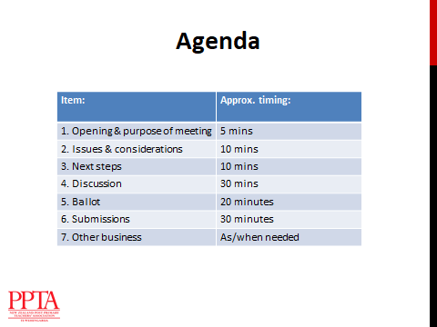

Here is a plan of the meeting

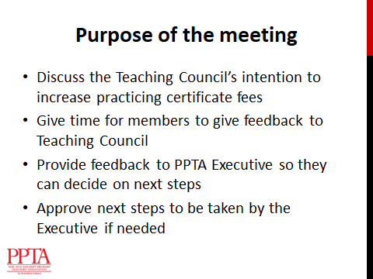

The purpose of our meeting today is to make sure that you have full, accurate information about the Teaching Council’s proposed increase in registration and certification fees, and to allow you to take part in the consultation process, including time to complete a written submission to the Teaching Council. You will also be given opportunity to provide feedback to PPTA and approve the Executive to take further steps if needed.



There are two main issues to consider: the proposed increase itself, and the nature of the consultation process offered by the Teaching Council.



The Teaching Council has announced that it intends to increase registration and certification fees for teachers from 1 July 2020. It has called for consultation, but it only wants discussion on two options.   
The first option is an increase fees from $221 to $470 for all teachers. The second option is that new graduates (pre-registered teachers) would pay a fee of $300, and all others would pay $500. A large part of this increase is to fund the new Centre for Leadership Excellence within the Council, which is intended to provide professional development to those in leadership positions in schools. The Council lobbied to have this instead of the Ministry of Education operating it under its budget.



When asked by the Teaching Council about fee increases in its 2018 consultation process teachers rejected the idea strongly. This time the Council has given a number of reasons for this going ahead with an increase. It argues that it cannot fund its activities at the current level of fees, and has not increased its fees since 2010. In this time it has experienced increased costs from the development of the Centre for Leadership Excellence. This Centre was Labour Party policy which became a Government initiative up their election. The Council has also experienced increased referrals to Disciplinary Tribunal which have increased staffing and resourcing costs, and of course there has been inflation in that ten year period. The Teaching Council has been receiving a Government subsidy to cover this shortfall, but this funding is scheduled to end on July 1st of this year unless the government changes its mind.



An increase in fees of this size obviously has serious implications for teachers. As individuals, teachers are facing a cost increase of 125%, or more than double the current amount. There are also impacts on the teaching profession as a whole, as this will create a further barrier to teacher supply at a time when we are already experiencing significant shortages. Lastly there is the question of equity. A blanket fee falls disproportionately on part timers, day relievers and establishing teachers.



If the Teaching Council cannot fund its activities with its current fees, one alternative is for it to reduce its costs. This could be done for example by more efficient competence/discipline processes or by making the PLD opportunities provided by the Centre for Leadership Excellence pay-as-you-go, rather than all members covering the costs of this Centre which they may not be using, or this Centre could be relocated into another Government agency location entirely, so that its services would still be available to teachers but not at their own cost. By reducing costs, the Teaching Council could either keep fees at the current level, or limit the rise to the cost of inflation, which would take fees to around $260.

However, it may not be in teachers’ best interests to have a Teaching Council which struggles to exist within its funding or which is very limited in its ability to carry out its core functions. Therefore it is also worth considering whether, since it is the government which requires that teachers are registered, a better option might be that the Teaching Council is fully funded by the Government, or that the Government increases schools’ operations grants so that Boards of Trustees, who are our direct employers, can pay the cost of registration and certification for us just as many other state sector employees, such as nurses and Social Workers have their registration costs covered by the employers who employ them and use their skills. The Ministry of Education itself pays the professional association fees of its employees.



If the Teaching Council does not change its suggested fee increases following the submissions, PPTA members will need to take further action. Because the Teaching Council fees are not part of current Collective Agreement negotiations we cannot legallygo on strike. A boycott of the fees is also difficult because teachers pay their registration and certification fees at different times. We would be asking just those teachers whose registration is up for renewal between now and July 1st to put themselves at risk of being unable to continue their employment because they no longer hold a practicing certificate.

There are other options we can consider, such as public protests, lobbying MPs and other relevant groups, or boycotting other Teaching Council activities such as requests for consultation and elections.



***This is the end of the speech, but the Powerpoint continues. It will lead you through the voting process and how to write a submission to the Teachers Council.***