PPTA Te Wehengarua Annual Conference 2023

Thinking Differently
Inclusion for Neurodiverse Kaiako in Education

A PAPER FROM THE PPTA Tāmaki Makaurau Auckland REGION

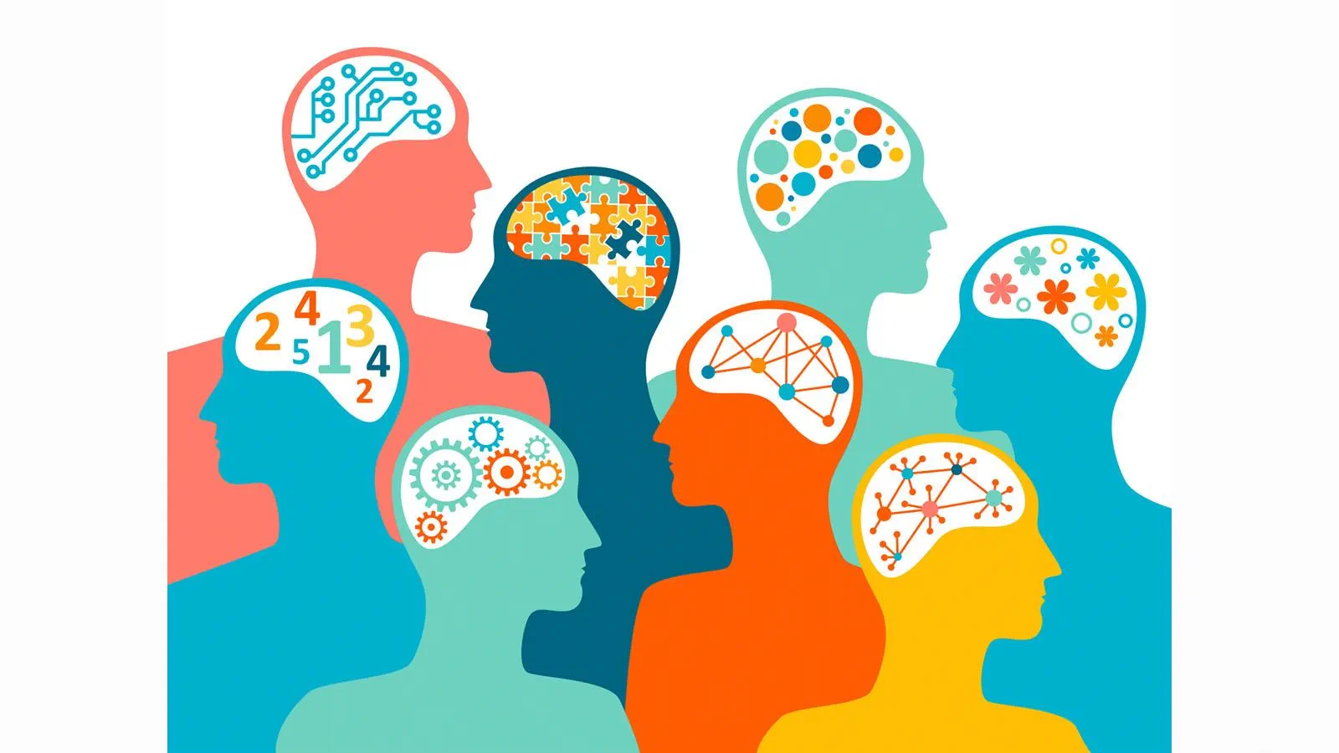

CONTENTS
Recommendations 2
1. Introduction 3
2. Affirming Diversity 3
3. Advisory Committee Necessity 4
4. Conclusion 5
5. Endnotes 5

Recommendations
- That the report be received.

- That the strengths of neurodiverse kaiako in kura be officially recognised by PPTA Te Wehengarua

- That a Neurodiverse Network for neurodivergent members be formed with associated branch representative positions where relevant.

- That an associated advisory committee:
  - Be convened to report to annual conference in 2024 and beyond with recommendations on:
    - systems to best utilise and recognise and support the unique abilities of our neurodiverse kaiako
    - addressing challenges faced by neurodiverse kaiako in kura across the country.
  - Be made up of five to seven individuals and include an Executive Member, a Te Huarahi Member, and a provisionally certificated teacher or a pre-service teacher.

INTRODUCTION

  - Neurodiverse individuals exist across society, and the category itself indicates a difference in cognitive processing. There is recognition that various neurodiverse students may struggle in education, but what about educators? States of being and ways of thinking and perceiving information related to being neurodiverse do not, generally, go away with age, a neurodiverse individual may just find better ways to manage or hide these things. These differences are not a negative, either, when utilised in the appropriate manner.

  - Neurodiverse kaiako have a range of benefits they can bring to the table, such as an autistic teacher’s hyperfixation in their specialist subject area or an ADHD kaiako’s way of connecting different concepts can engage otherwise disengaged students or a dyslexic teacher recognising new ways to communicate and present written medium learning. Presently the only manner in which neurodiversity would be recognised is as a disability (Section 3.1.1(a)(vii)) which does not fully encompass the lived experiences of neurodiverse individuals.

  - While no studies have looked specifically at neurodiverse kaiako, it can be clearly recognised that neurodiverse staff across the workforce have challenges in the workplace. In some cases it is even before the individual enters the workplace as they are not hired due to the perception of failings. Many of these challenges are not the fault of the neurodiverse individual, but rather the perceptions of neurodiversity that people hold. It is often a case of a disabling system that results in neurodiverse kaiako being unable to fully show their value to said system.

  - Ultimately, if we can support our neurodiverse students, why not our neurodiverse staff?

2. Affirming Diversity

2.1 We currently affirm a range of diversities within the educational system, be it racial, sexuality and gender, disability or religious diversity. We do not yet recognise neurological differences beyond their disabling attributes. The teaching profession, as a microcosm of society, has members from all range of diversities, including neurodiversity, and so we should recognise the strengths and challenges that come with those diversities, across the board.

2.2 Neurodiverse individuals have a such strengths that can be an asset to teaching. Autistic individuals can be 140% more productive than your average employee when in the career they are passionate about. ADHD individuals' high theta wave levels mean they’ll be calm in crisis situations (something I’m sure we’ve all experienced at one point or another as teachers). Dyslexic individuals are shown to have excellent strategic thinking and higher emotional intelligence than neurotypical individuals. Currently these strengths are not always considered, the perceived deficits instead being given more weight in many situations. Being able to recognise these strengths and creating opportunities for those interested that are crafted around such strengths would allow neurodiverse kaiako to have greater opportunities to show their value in the workplace.

2.3 We currently draw on the strengths of our Rainbow Kaiako, our Māori and Pasifika Kaiako, our New and Emerging Kaiako, and others through various PPTA Networks, so why not have one for our Neurodiverse Kaiako? A Network for Neurodiverse Kaiako would allow for a place where people could look at their strengths and how they could best use them in teaching, and a more combined voice can then be used to better show schools that those values are beneficial, rather than just different.

2.4 Having this as an official PPTA Network would create a clear picture that the teaching profession values Neurodiverse Kaiako, which will also help for retention of Neurodiverse Kaiako.

2.5 Beyond this, we have more and more students identifying as neurodiverse, therefore having a network of teachers who have experienced being neurodiverse can then be leveraged for all teachers to be able to better understand neurodiversity and therefore serve their neurodiverse ākonga better.

3. Advisory Committee Necessity

3.1 Generally speaking, an advisory committee is attached to those PPTA Networks who will have unique challenges, such as the Rainbow Network or the Network of Establishing Teachers. Neurodiverse Kaiako experience a range of unique challenges, primarily rooted in the different ways in which they perceive reality and how that is not universally accepted.

3.2 An advisory committee for such a network would be able to seek positive solutions to challenges and work with kura and kaiako together to ensure an amicable result. Given differences in perception and sometimes in communication among neurodiverse individuals, this can result in a disconnect between neurotypical and neurodiverse staff. Clear processes and procedures that could be followed to maintain the dignity and respect of both parties could be developed by such a committee and would serve to smooth relations between neurodiverse and neurotypical staff.

3.3 Such a committee would also place a degree of authority in the hands of those experiencing these challenges, rather than those divorced from these challenges. Ultimately, much as a neurodiverse perspective cannot hope to truly know a neurotypical one, so too is it that neurotypical people cannot truly understand what it is to be neurodiverse. Having an advisory committee made up of neurodiverse individuals can then ensure that neurodiverse kaiako are not having their experiences diminished due to a lack of understanding.

3.4 The committee would have representatives from a range of regions and space for a couple of additional individuals where relevant (people particularly experienced with neurodiversity beyond their own experience or where a region seeks to have more than one representative for good reason).

3.5 This committee would be strongest if the committee has individuals of a range of neurodiversities as then there can be holistic support across the board for all range of neurodiversity. In some cases, some members of the committee may also have multiple neurodivergences and can then even speak to the intersectionality of different neurologies.

3.6 This committee would be selected based on self nominations followed by final selection by the General Secretary and the President.

3.7 Basically, neurodiverse challenges need neurodiverse voices in order to understand, unpack and address them. An advisory committee would be able to be those neurodiverse voices.

4. Conclusion

4.1 Neurodiverse kaiako exist and we should support them as best we can.

4.2 Neurodiverse kaiako have unique advantages that can benefit the whole teaching profession if properly recognised.

4.3 A Network of Neurodiverse Kaiako would serve to recognise those advantages.

4.4 An advisory committee attached to such a Network could ensure that there are available systems and guidelines to support neurodiverse kaiako so as to best leverage their strengths in the profession.

4.5 Such recognition could result in increased retention of neurodiverse kaiako and could result in improved learning for our neurodiverse (and otherwise) ākonga.

5. Endnotes
5.1 Definitions:
- Neurodiverse - An individual who has a neurology that has developed differently from what is considered normal. This can include Dyslexia, ADHD, Tourettes, Autism, Dyspraxia, Dyscalculia, etc. This can be recognised through official diagnosis or self-diagnosis.

- Neurotypical - “Refers to a person whose brain functions in a way that is considered the norm. What is considered the norm can vary depending on many factors.” This is generally assumed to be the case if there is no official or self-diagnosis of another neurology.

