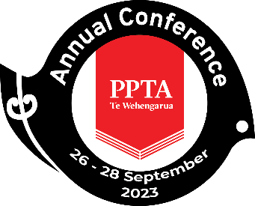

PPTA Te Wehengarua Annual Conference 2023

Flexible Learning Spaces – an update

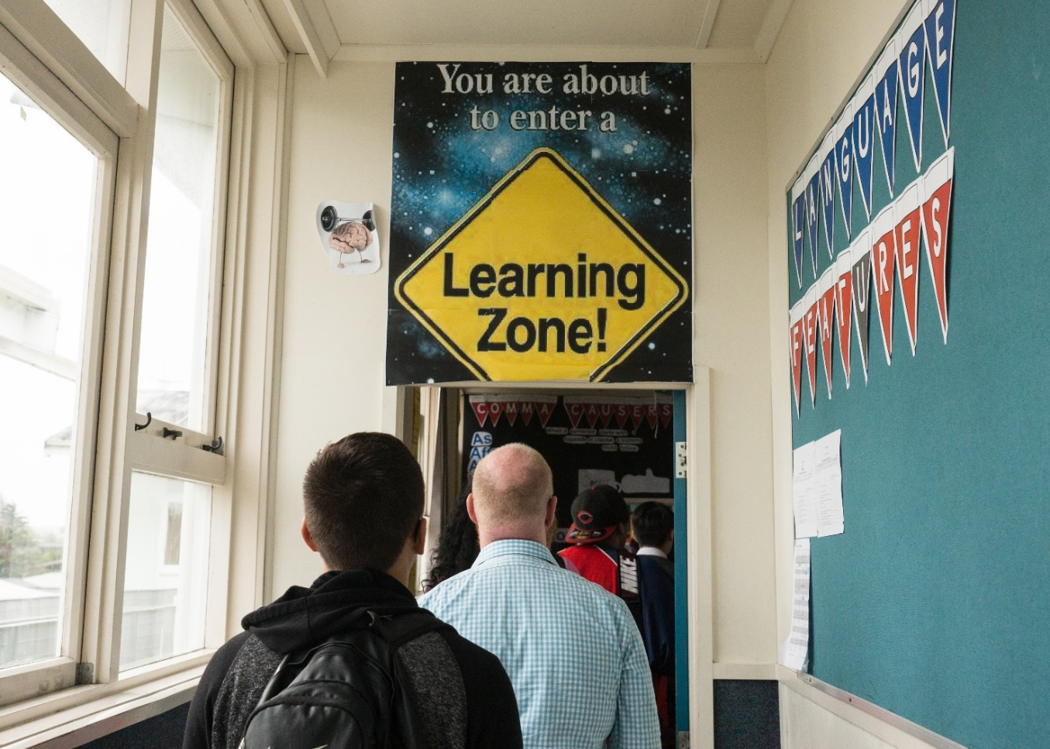

CONTENTS
Recommendations 2
1. Introduction 3
2. Developments since the paper 3
3. Evidence – is there any? 4
4. “No evidence , no evaluation, no exit” 5
5. Concerns around the process 6
6. Culturally responsive practice 6
7. There is no ‘one size fits all’ in education 7
8. The recommendations 8

Recommendations
- That the paper be received.

- That PPTA Te Wehengarua continues to affirm that we welcome thoughtful, evidence-based, teacher-consulted and coherent change in secondary schools.

- That PPTA Te Wehengarua continues to challenge the Ministry of Education on the need to research the effectiveness of flexible learning spaces in terms of their impact on aspects such as student achievement, student and teacher wellbeing, teaching and learning, and teacher satisfaction in the Aotearoa New Zealand context. This research must then be made readily available to all schools.

- That PPTA Te Wehengarua continue to advocate for the government to dedicate additional funding for PLD for teachers in rebuilt flexible learning space schools as a proportion of the total projected cost of the physical build.

- That PPTA Te Wehengarua advocate for the Ministry of Education to ensure culturally inclusive practices, learning environments and pedagogies, embedded in mātauranga taketake, are developed and transparent in all areas of education, including in the planning and building phase.

- That PPTA Te Wehengarua supports branches to make renewed efforts to persuade their boards of trustees to sign up to an education change management policy for the school, based on the processes outlined in PPTA Te Wehengarua Education Change Management Toolkit.

- That PPTA Te Wehengarua establish a Flexible Learning Spaces Taskforce as a vehicle to support the recommendations in this paper.

Introduction
  - This is an update for the 2017 Conference Paper Flexible Learning Spaces: An Experiment on our Education System? ¹ That paper outlined some of the issues associated with the shift towards flexible learning spaces (FLS) also known as ILE (Innovative Learning Environments) and the lack of evidence to support this shift.

  - It is worth noting that a FLS is not necessarily an ILE; for a space to be innovative, the pedagogy needs to be innovative. Without innovative teaching practice, it is only an ‘open plan’ environment.

  - The 2017 paper proposed the need for additional funding and for specific professional learning and development (PLD) for teachers working in these spaces. There was also a call for the level of PLD provided to new schools to be matched for schools who were undergoing a rebuild process, with inequities in the funding for these schools acknowledged.

  - With our self-governing schools, it is no surprise that there are a multitude of types of school in Aotearoa New Zealand, ranging from extremely ‘traditional’ single-cell classrooms right through to cutting-edge ‘innovative’ learning environments. We have members who love teaching in ILE, those who prefer a single-cell classroom, and there are students who thrive in one but not in the other.

  - This paper does not make assumptions or judgements about FLS or ILEs. What this paper is asking for is research into the effectiveness of flexible learning spaces in Aotearoa New Zealand; and for that research to be made available to schools. The recommendations of the paper are taken directly from the 2017 paper (with some changes), and it is disappointing that we do not seem to have seen much progression in that time.

Developments since the paper
  - Just after the 2017 conference, a Ministry of Education-sponsored study, undertaken by The University of Melbourne (UoM), was published and echoed many of the recommendations of the conference paper.

  - The preliminary results of that study can be found in a journal article, The ‘state of play’ concerning New Zealand’s transition to innovating learning environments: Preliminary results from phase one of the ILETC project. ILETC stands for Innovative Learning Environments and Teacher Change, a project of the University of Melbourne’s Learning Environments Applied Research Network (LEARN).

  - While the preliminary results appear positive: “…open plan learning spaces lead to higher teacher mind frames and student deep learning”, the conclusion is more ambivalent and calls for evidence on the impact of these transitions (to FLS). There is, however, a call for more research into the effectiveness of “transition…to direct meaningful and sustainable improvements in student learning outcomes”.

  - A 2021 text Teacher Transition into Innovative Learning Environments holds a plethora of information on the building and use of innovative learning spaces (including the UoM study). It would be worth a read for any school about to embark on a new build or rebuild project.

  - In 2018 an independent taskforce conducted a system review of Tomorrow’s Schools and one of the recommendations was to remove property decisions from school boards. This was watered down to the following statement:

“The Ministry of Education will provide advice on the feasibility and cost of taking on more property related responsibilities from Boards over the next 5 to 10 years, while ensuring schools and communities continue to have significant input into the design of their physical spaces”.

  - Regardless, the onus is on boards to “ensure that decisions about how school property should be used will improve education outcomes for students”.

  - In 2019, the MoE published Te Rautaki Rawa Kura: The School Property Strategy 2030. The language used is now ‘Quality Learning Environments’ (QLE) that “deliver equitable and excellent outcomes for every child”. By definition, a QLE meets ‘standards across three elements – condition, fitness for purpose and operational efficiency’. Boards must be empowered with up-to-date and relevant evidence when making decisions about their property – be it a new build, a rebuild or a minor renovation.

Evidence – is there any?
  - Without anything concrete, this paper once again challenges the MoE on the pressing need to research the effectiveness of FLS with regards to their impact on student achievement, student wellbeing, teaching and learning, and teacher satisfaction in the New Zealand context. It may be that further findings from the UoM study will soon be released, and we can report on those if and when they appear.

  - In 2015 and 2016, the MoE commissioned and funded ‘Post Occupancy Evaluations’ for all new and rebuilds. This has not continued, and questions to the MoE about this have yet to be answered.

  - Often there is ideological division in terms of what constitutes ‘sound pedagogy’; it would be preferable for the profession if decisions being made around such crucial factors affecting teacher workload and student learning were based on evidence.

  - Some evidence can be found in the Education Review Office reports of schools who would classify as being MLE/FLS/ILE. A read through many of these suggest that there is no glaring problem with teaching and learning in these spaces and include positive comments.

  - The 2019 ERO report for Hobsonville Secondary School, a high-profile new build in north-west Tāmaki Makaurau Auckland finds that the school provides a “responsive and relevant curriculum design that promotes innovation, critical thinking and future-focused pathways for students”¹⁰. It goes on to say that “[p]rofessional learning for staff is a priority and is centred on specific educational outcomes, including students knowing themselves as learners. This is supported by highly effective communication and collaboration in sharing strategies for improvement and innovation”¹¹. Clearly, when you prioritise staff learning, they are able to provide the innovative learning for students.

  - For Rolleston College, a school mentioned in the 2017 conference paper, the comments are equally positive with regards to teaching and learning, with “… strong relationships learners value with their teachers and each other, [a] curriculum that is responsive and promotes meaningful, integrated opportunities with the learner at the centre, and …[l] leaders who are future-focused and committed to the aspirations of the school’s growing community”¹².

  - In July of this year it was announced that “the construction of open learning classroom”¹³ in New South Wales schools would end. Crucially, these were originally undertaken with architects leading the way rather than teachers. The NSW Teachers Federation said “they had been fielding complaints about the unsuitability of the classrooms since about 2018”¹⁴.

  - Henry Rajendra, NSWTF Vice President also said “…it was a misnomer to describe many open-plan learning classrooms as “flexible learning spaces” because they had not been built with sound-absorbent walls which could be moved to create smaller spaces”¹⁵.

  - In the NSW context, plans for new public schools will use “learning hub layouts”, which are used as a starting point for school designs, including learning spaces which allow for movement and collaboration across classes.

“No evidence , no evaluation, no exit”
  - In 2022, right-wing ‘think tank’ The New Zealand Initiative (NZI) published a report on the ‘modern learning environments experiment’. While NZI is ideologically poles apart from PPTA Te Wehengarua on many issues, the recommendations of the report are not unlike our own current policy.

  - The report calls for research into ‘self-directed learning as a pedagogical strategy’ and to determine if ‘direct instruction’ could be effective in ‘both ILEs and traditional classrooms’. Regardless of the learning environment, the opportunity to understand how best to enhance teaching and learning is something we will always support as policy.

  - They also call for a funded ‘systematic programme of professional development for [all] teachers’ regardless of their teaching environment, resources and professional development ‘to support the learning of students with learning disabilities’, another clear PPTA Te Wehengarua policy.

  - The final two recommendations are that the Ministry of Education ‘undertake a comprehensive retrospective evaluation of teaching and learning in ILEs’ and a call that ‘no teaching and learning initiatives should be undertaken by the MoE without a prima facie case’ backed by research and accompanied by a framework for monitoring and evaluation.

  - On the one hand, the NZI report claims there is no evidence to suggest that ILE enhance students’ learning, but neither is there evidence to suggest that the opposite is true (when the spaces are used well). Indeed, the Bradbeer et al report discussed earlier in this paper simply suggested that more evidence is required but also that ‘preliminary findings [show that] traditional classrooms are associated with markedly lower characteristics of positive teacher mind frames and student deep learning’.

  - PPTA Te Wehengarua fully supports the call for research into how best to provide quality schooling for all ākonga – whether in ‘traditional classrooms’ or ILEs.

Concerns around the process
  - In speaking to some principals, there is a concern that the MoE is moving towards the concept of ‘super schools’. With land being in short supply in many areas with booming population growth (and a full new build, with the need to first acquire land, being an expensive and time-consuming process), some schools are being asked to increase their rolls and undergo even more building projects on their site. This may be the way of the future, but it needs to be properly thought out and planned; it’s not as simple as doubling the buildings and carrying on as usual.

  - Every school will be different, and it is important that designers understand the way that the students and staff use the space.

Culturally responsive practice
  - There have also been concerns around the consultation process with mana whenua and local community in both new and re-builds. Rather than moving at pace, and expecting iwi and community to meet arbitrary timelines, it is important that true and authentic consultation be undertaken with all stakeholders.

  - Indeed, the MoE property strategy Te Rautaki Rawa Kura commits to the principles of Te Tiriti o Waitangi, supporting mana whenua to exercise ‘tino rangatiratanga when making decisions about school property’. What is concerning is that unless they are able to be counted as a classroom, marae are not funded centrally, and instead are contingent on locally-raised funds. In practice this usually means that the planning for school marae happens after the ‘main’ body of the school has been planned (and often well after it has been built).

  - This paper once again is a reminder that our Educational Change Management Toolkit is invaluable for all schools involved in any change – be it the buildings or what happens within those buildings. It is in the process of being updated but as it stands is still a very useful tool.

There is no ‘one size fits all’ in education
  - We have many members who thrive in an ILE, and likely just as many who find it stressful. There is research to show that students with ‘speech and language difficulties, learning difficulties, cognitive disorders, attention disorders and behavioural problems’ will struggle to learn in noisy learning environments (a common criticism of ILE).

  - In her paper Innovative Learning Environments, Are They Inclusive? Why Evaluating the Speaking, and Acoustic Potential of the Space Matters, Leanne Rose-Munro reiterates that we must work towards more inclusive educational environments as the majority of students mentioned above are ‘attending mainstream schools in their local communities’.

  - For those who have no choice, there is evidence to suggest that the use of sensory reduction zones known as ‘sensory nooks’ have great value along with the use of a buddy system or ‘trusted other’. To be more inclusive, building design must have all learners in mind. Another common finding of the studies cited in this paper is that the teachers and learners are not always given full and detailed information on how best to use the FLS/ILE they are now inhabiting. There needs to be a better connect between the designers of these spaces and the ‘end users’: our teachers and our learners.

  - Education academics from Latrobe University in 2013 noted flexible learning spaces promoted flexibility, visibility and scrutiny and were a reaction against the “industrial-era enclosed and authoritarian classroom”

  - Another study conducted in New Zealand Aotearoa also shows that, where properly resourced, teaching and learning in innovative learning environments can be [very] conducive to learning.

  - The study found that “…it is the teachers, as capable mediators between the affordance of innovative learning environments and suitable pedagogical practices, who are the catalyst to change’. The positives of ILEs shown in the study are the ability to be flexible and collegial, allowing teachers to cater to a “wide range of learning needs”; the downsides are around high levels of noise and associated issues with “effectively managing students’ behaviour”. There was also some concern around the disconnect between pedagogical styles of some teachers who share a learning space.

  - Again, the building of an FLS/ILE does not automatically lead to innovative teaching practice; teachers need time and resourcing to plan and prepare for the change. Effective team teaching requires “collaboration in many areas, such as timetabling, course planning, and assessment discussion”, requiring professional trust (and the time to develop relationships) between teachers. You cannot make such changes without leadership, learning, time and space.

  - We need a coherent approach to PLD for teachers in these learning environments; it must be resourced at a central level and not take away from the ‘pot’ of property funding.

The recommendations
  - Recommendation two continues to reiterate that PPTA Te Wehengarua welcomes thoughtful and coherent change in secondary schools. Change is difficult and requires time and space for individual teachers, as well as smaller teams and the whole school to make those thoughtful adjustments.

  - It is disappointing that we are still asking for research into the effectiveness of flexible learning spaces in terms of their impact on student achievement, student wellbeing, teaching and learning, and teacher satisfaction in the Aotearoa New Zealand context. If school boards and school communities are to make informed decisions, this research must then be made readily available to them.

  - When research is made available, there also needs to be resourcing for schools and teachers to develop their practice. As we see fewer new builds being commissioned, additional funding must be made available for PLD for those teachers in rebuilt flexible learning space schools as a proportion of the total projected cost of the physical build. It cannot be down to schools to make decisions between extra toilets or quality professional development. As discussed in the 2017 conference paper, new builds have been provided with more paid lead in time for staff, giving them the opportunity to develop their practice in the new space.

  - Culturally inclusive practice within our schools is improving but in a haphazard way. We are calling for this to be further developed in all areas of education, including in the planning and building phase. Recommendation five makes it clear that this cannot be done with arbitrary time frames and must be transparent and authentic.

  - Recommendation six is that PPTA Te Wehengarua branches make renewed efforts to persuade their boards of trustees to sign up to an education change management policy for the school, based on the processes outlined in PPTA Te Wehengarua Education Change Management Toolkit. The toolkit is in the process of being updated and will be a powerful tool for branches to ensure that change is managed in a workable and coherent manner.

Chris Bradbeer, Marian Mahat, Terry Byers, Benjamen Cleveland. Tom Kvan and Wesly Imms, “The ‘state of play’ concerning New Zealand’s transition to innovating learning environments: Preliminary results from phase one of the ILETC project”, Journal of Educational Leadership, Policy and Practice 32:1 (2017), pp 22-38
Ibid
ibid
Wesley Imms, Thomas Kvan eds. Teacher Transition into Innovative Learning Environments: A Global Perspective, (2021)
Ministry of Education, Conversation, Information for Boards of Trustees, website
Ministry of Education, Te Rautaki Rawa Kura The School Property Strategy 2030, (2019),
Ibid, p 4
Ibid
Ministry of Education, Te Rautaki Rawa Kura The School Property Strategy 2030, (2019), p 6.
Leanne Rose-Munro, “Innovative Learning Environments, Are They Inclusive? Why Evaluating the Speaking, and Acoustic Potential of the Space matters (2019)
ibid.
Ibid
ibid
End of ‘a 40-year-old fad’ as NSW shuts door on open-plan classrooms,
Jo Fletcher, John Everatt, Yogeetha Devi Bala Subramaniam & Ting Ma, “Perceptions About Innovative and Traditional Learning Spaces: Teachers and Students in New Zealand Primary Schools”, (2023)
Ibid, p.147
Ibid, p.142
Ibid, p.141
Ibid, p.147

