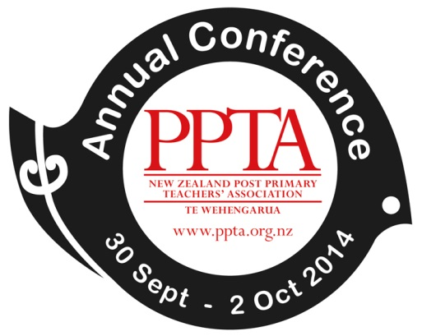

Report to Conference Delegates

Executive and Presidential Electoral Processes

- At the 2014 Conference a notice of general business was submitted regarding an examination of executive and electoral processes in light of the earlier constitutional change to the maximum number of terms a member could serve as President to four years.

- As time did not allow for the notice to be tabled or debated at Conference itself, the Executive subsequently decided to act upon the notice and to initiate its own examination of the issues raised. A sub-committee has been established to do this work and it is expected to report to the November 2014 Executive meeting.

- The general business notice assumed that a report to the 2014 Conference recommending further constitutional change regarding the presidential term might be required. However, the issues raised in the notice have more to do with the electoral processes, candidate visibility and support for office holders. These are operational matters in the main rather than constitutional. Thus, the Executive will not be tabling any constitutional amendments this year.

