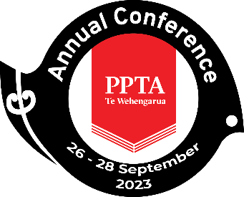

PPTA Te Wehengarua Annual Conference 2023

LABORATORY MANAGERS – A REPORT FOR ANNUAL CONFERENCE

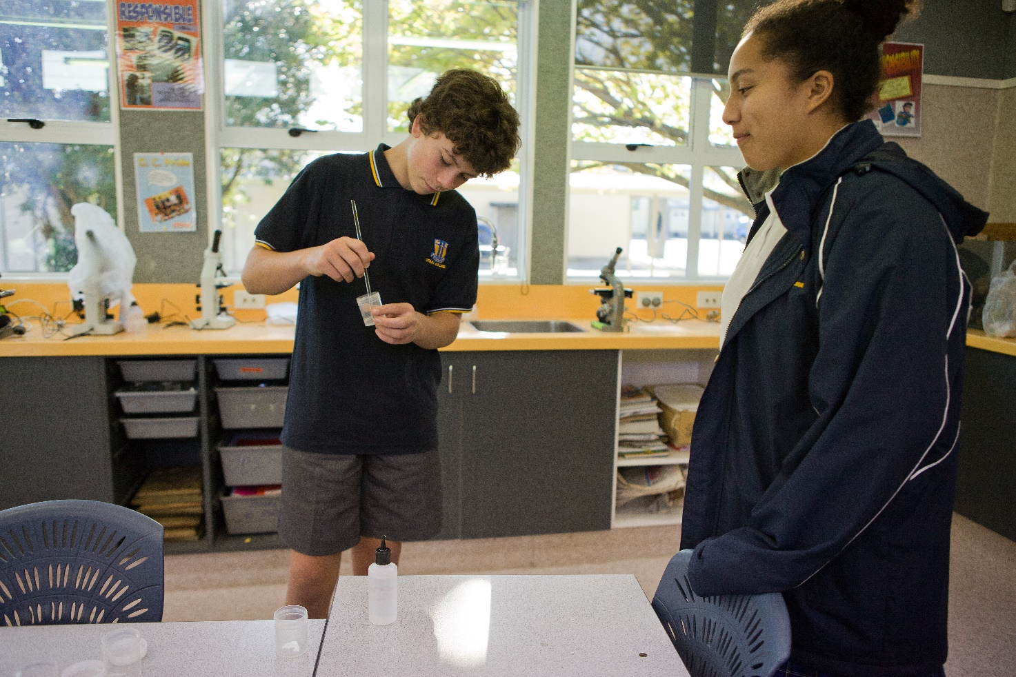
CONTENTS
Recommendation 2
1. Introduction 3
2. Timeline 3
3. Final Report 3
4. Next Steps 4
5. Appendix 5

Recommendation
- That the report be received.

INTRODUCTION
  - At the 2020 Annual Conference the Waikato Region presented the paper “School Laboratory Managers”. One of the recommendations on this paper was:
That PPTA commissions an external job-sizing exercise for the laboratory manager role in a range of schools, to determine appropriate time and remuneration levels, and report these findings to the 2021 Annual Conference.

  - A report providing an update on progress on this work was given at the 2022 Annual Conference. This report outlined progress and challenges.
  - This final report includes a copy of the external job-sizing.

TIMELINE
2.1 Various attempts were made to contract this work to an external organisation through 2021 and into 2022. It proved challenging to find the right provider to complete this work.

2.2 Alongside this we attempted to gather information using the networks and information we have as a union. COVID proved challenging, causing disruption within our schools, we were unwilling to apply additional pressure to teachers. The small number of responses we received supported all the previous work done to write the original 2020 Annual Conference paper – that people are not compensated in any way for this work, which is taking one to two hours a week.

2.3 Complicating the situation was a change to the guidance for schools around safety in science. In May 2022 the Ministry of Education published ‘Safety and Science/Pūtaiao: Guidance for Aotearoa New Zealand Schools and Kura’.

2.4 This new document shifted some of the liability onto classroom teachers, and as such may impact the work done by the designated laboratory manager.

FINAL REPORT
3.1 In 2022 we were put in touch with Geoff Summers, a human resource management specialist. Working with the New Zealand Association of Science Educators (NZASE) he was able to gather relevant information from 69 laboratory managers in schools.

3.2 The report prepared by Geoff Summers (attached) includes 12 recommendations for PPTA. These recommendations will now be considered by the union and where appropriate, action taken.

NEXT STEPS
4.1 This report is substantial, and the process of considering the recommendations will take time.

4.2 It is planned that a paper will be presented to the 2024 conference that outlines what has been done and what still needs addressing. This will be particularly important for recommendations that underpin conditions claims.

Appendix

https://scienceonline.tki.org.nz/content/download/1611/21493/version/2/file/MOE-School+Labs+Guidance.pdf
https://nzase.org.nz/wp-content/uploads/2022/04/2022-05-Safety-in-science-teaching-NZASE-guide.pdf

