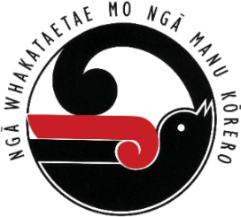
Application for TRD days for Ngā Manu Kōrero
Schools should use this form to apply for TRD reimbursement for teachers involved in regional and national Ngā Manu Kōrero competitions. Regional coordinators will be responsible for endorsing TRD claims before they are sent to PPTA Te Wehengarua. See Handbook p.24 for TRDs reimbursed by the Ministry of Education.
Please note, if you are claiming for the national competition, the Ministry will reimburse all in Term 4. They will use the formula as outlined in Additional relief teacher funding – Education in New Zealand
NAME OF SCHOOL: SCHOOL NUMBER:
Name of Teacher | Days for regional competition  (2 teachers x 3 days) | Days for national competition  (4 teachers x 3 days) | Regional Coordinator  (5 days)
Principal’s name: ……………………………………………………………… Signature:
RETURN FORM TO YOUR REGIONAL COORDINATOR (see p.19 & 20 in the handbook)

