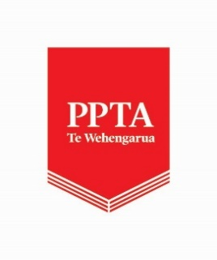
Vacancy – Surplus Staffing Nominee (voluntary role)
We are currently seeking additional new Surplus Staffing nominees in all regions with knowledge and ability in Te Reo and/or Te Ao Māori.
A Surplus Staffing nominee is a required and critical role for the Association in surplus staffing situations. Training in the role will be provided in term three and mentoring will occur. Work as nominee could commence as early as term four.
If you are a current PPTA financial or honorary member and have a:
- A commitment to the Association’s constitutional objectives
- Knowledge and ability in Te Reo and/or Te Ao Māori
- A commitment to supporting members’ collective interests

And

- An ability to understand staffing and timetabling
- A willingness to receive training (annually) and to be available to work as surplus staffing nominee in term four and possibly from time to time during the year
- An ability and desire to be familiar with the Surplus Staffing provisions in the ASTCA and STCA
- Experience in working with spreadsheets
- An analytical mind
- Clear, concise, and professional written and verbal communication skills

Or
- A willingness to work alongside a nominee, and guiding and supporting and/or leading in aspects of Te Reo and Te Ao Māori

If you are interested in this role, click this link to access the application form
If you require more information, please contact the Deputy General Secretary (Membership) – Adele Towgood, atowgood@ppta.org.nz
The closing date for applications is Sunday 30th June 2024

