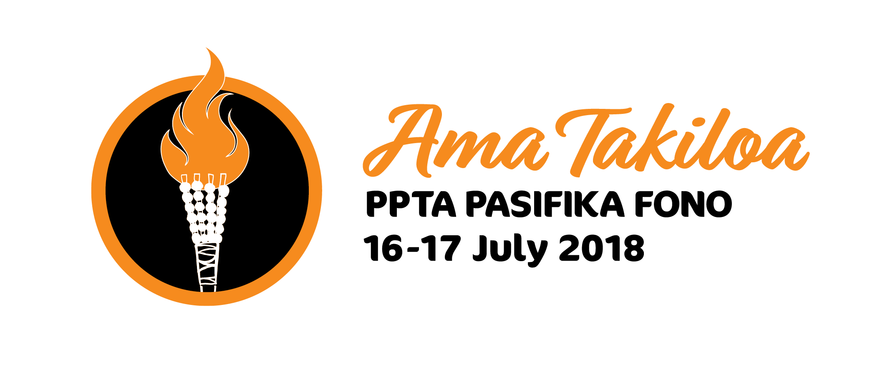

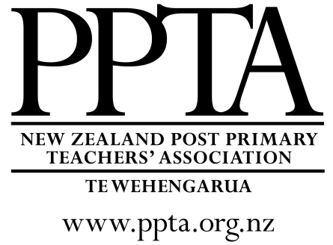
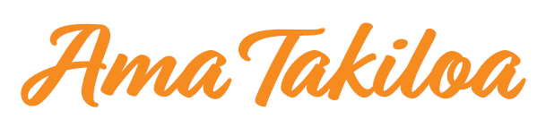

Kia ora, Kia Orana, Talofa lava, Fakalofa lahi atu, Malo e lelei, Taloha ni, Kam na mauri, Ni sa Bula, Namaste, Halo olgeta, Aloha!

On behalf of PPTA and Komiti Pasifika I extend a warm welcome to you as you attend this year’s fono – Ama Takiloa.

Ama Takiloa (Tonga)
Rama Arataki (Cook Islands)
Hulu e Hala (Niue)
Faamalamalamaina o le ala (Samoa)
Taohi te moli ke malama ai te aûala (Tokelau)
Na vakararamataki ni Gaunisala (Fiji)

The theme of this year’s PPTA Pasifika Fono is “lighting the way” based around the concept of holding a torch to light the path ahead. The symbol of the torch is commonly used to represent enlightenment and hope. Indeed, the intention of the conference logo is to call for Pasifika teachers and teachers of Pasifika students to be torch carriers for education in Aotearoa today.

PPTA Komiti Pasifika hopes that the conference programme will assist all who attend in being able to light the way for ourselves, our communities and our students. We have been thoughtful about including speakers and workshops that will enlighten, lift up and give us things to take away that will help us make a positive difference.
Without a doubt, “we cannot hold a torch to light another's path without brightening our own” (Ben Sweetland).

I look forward to the opportunity of meeting with you and being energised by the light you bring as we participate together in this year’s Fono. Thank you for giving up your term break time to be here with us. I am sure it will be time well spent and enjoyed!
Kia Manuia!

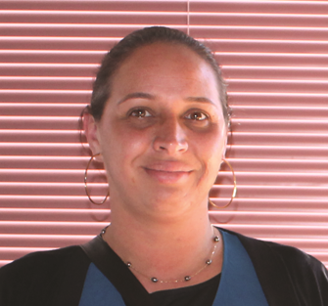

Natalie Faitala
PPTA NATIONAL EXECUTIVE MEMBER FOR KOMITI PASIFIKA

Programme

Monday 16 July

9.00am | Registration
9.30am | Opening ceremony:  - Mihi whakatau  - Devotion: Rev Ali’itasi Aoina-Salesa  - Samoan welcome: Faumuina To’aletai David Tua  - Welcome: Jack Boyle, PPTA President
10.15am | Morning tea
10.45am | Keynote speaker 1: Hon. Jenny Salesa  Associate Minister of Education
11.30am | Workshop 1: Lighting the way for ourselves  - Faia’oga manuia!  - Stressing less  - Introduction to unconscious bias  - Let your soul glow – self-improvement and effective practice
12.30pm | Lunch
1.30pm | Keynote speaker 2: Fa'anānā Efeso Collins  Auckland City Councillor
2.15 pm | Workshop 2: Lighting the way in our communities  - Designing Pasifika Community Liaison positions  - What is Pasifika success  - Engaging and motivating Pasifika fanau as a non-Pasifika teacher  - Shedding light on the dark areas
3.15pm | Afternoon tea
3.45pm | Healthcare Plus
3.50pm | PPTA Networks update
4.10pm | Plenary notices
4.15pm | Fono bingo (followed by free time)
6:00pm | Drinks
6.30pm | Fono dinner with entertainment
Tuesday 17 July

7.00am  -7.45am | Hulanesian Fitness: Liz Tupuhi (Richard Pearse room)
9.00am | Opening prayer/pese: Teokotai Tarai
9.10am | Tapasa update
9.15am | NZQA update
9.30am | Youth Panel: Southside Rise
10.15am | Morning tea
10.45am | Keynote 3: Vito Nonumalo  Emerge Aotearoa
11.30am | Market Place  - Making leis, ribbon leis, lolly leis  - Demonstrating making ei katu (flower head crowns)  - History and preparation of kava ceremonies  - Sasa dance for beginners
12.00pm | Market Place  - swop to second choice
12.30pm | Lunch
1.30pm | Workshop 3: Lighting the way in our classrooms  - Planning for university domains  - Hangi and Umu – integrated NCEA studies and credits  - Brown, bilingual, brainy and beautiful  - Teaching the Pacific Studies standards
2.30pm | Heads Held High
3.15pm | Cultural performances from market place sessions
3.30pm | Tofa soifua
4.00pm | Afternoon tea

Workshop 1 Lighting the way for ourselves | Monday 11.30am – 12.30pm
Topic | Presenter | Room
Faia’oga manuia!  The way to leadership and authority is through service. This workshop is to encourage Pasifika teachers to display, demonstrate and role model “the best Pasifika teacher”. | Taulapapa Joy Tualima | Amy Johnson
Stressing less  Fun activities for destressing. Minimising stress helps one to remain resilient which is an important trait for teachers to maintain in their leadership roles at school. | Marina Potter and ‘Alisi Tatafu with Toko Tautua students | Richard Pearse
Introduction to unconscious bias  Understanding unconscious bias is a key step in developing an inclusive workplace. A burgeoning body of research has empirically demonstrated the existence and prevalence of unconscious bias - unconscious beliefs and attitudes that go beyond our regular perceptions of ourselves and others.  The good news is that there are specific tools and strategies that we can employ at both the individual and organisational level to help reduce the impact of unconscious bias and to become more inclusive. | Vasa Cynthia Collins | Amelia Earhart
Let your soul glow - self-improvement and effective practice  How do you feel about PLD and its connection to your practice? Too often we can be bombarded with the latest PLD that your school has signed up for, which may not necessarily fit with your inquiry focus or you may think just adds to your teacher workload. Are you curious about undertaking further study but don't know what options to take? The best teacher is one who continues to learn. This workshop will focus on providing learning strategies for teachers of Pacific learners and what they can do to upskill their practice. We will also look at ways that you can develop a learning mindset that helps you to elicit success from our Pacific students and ultimately, reinvigorate your passion for teaching to let your soul glow. | Aiono Manu Faaea-Semeatu | Jean Batten 1&2

Workshop 2 Lighting the way in our communities | Monday 2.15pm – 3.15pm
Topic | Presenter | Room
Designing Pasifika Community Liaison positions  An interactive workshop to develop criteria, a good job description and expectations for teachers in this proposed new role. | Rob Willetts | Richard Pearse
What is Pasifika success as Pasifika: students and parents speak  This workshop will discuss the issue of defining success in Pasifika education. It is an affirming look at the subject.  It will describe a research journey for those who wish to inquire into Pasifika education. It will suggest a language in which to describe Pasifika success. It will show practical implications for teachers to light the way for Pasifika success in classrooms. | Martyn Reynolds | Amelia Earhart
Engaging and motivating Pasifika fânau ako as a non-Pasifika teacher  Members at the workshop will share their knowledge, experience and skills to create tools and resources for teachers to use in the classroom in a secondary age group setting. | Brian Dunckley | Amy Johnson
Shedding light on the dark areas  Beginning with my own, and some of my nearest and dearest’s, experiences with the negative aspects of participating in a collectivist Samoan culture. Personal, and wider observations (of colleagues and researchers), of how similar behaviours are echoed in the Samoan teenage learners of today.  Talanoa session – what do teachers at the workshop think about this? Is it something we can all work together to help address? If so, how? | Natasha Ah Tune | Jean Batten 1&2

Workshop 3 Lighting the way in our classrooms | Tuesday 1.30pm – 2.30pm
Topic | Presenter | Room
Planning for university domains  This is an opportunity for teachers to plan ahead with their extra-curricular and program to support gaining University domains through Dance and Languages, and other subjects.  We can share ideas, and standards, programs as to how we can make a greater impact for our students, especially where these subjects are not offered as classes. | Teokotai Tarai | Amelia Earhart
Hangi and Umu- integrated NCEA studies and credits  Integrating culture into your teaching. Students getting cross- curricular credits from doing one unit, extending the students, community involvement. | Sujata Rajagopal | Richard Pearse
Brown, bilingual, brainy and beautiful - generation B to the power of 4  Teaching in the Gate way of South Auckland Mangere, in one of the decile one South Auckland secondary school. Keep Generation B to the Power of 4- Brown, Bilingual, Brainy and Beautiful students engaged in their learning. What does this look like?  This AKO workshop is based on the premise that shifting teachers’ thinking and practice from a more face-to-face interaction with students, to a blend of this mode plus online learning, sharing other best practice and interactive learning tools, would minimise students’ disengagement in the classroom.  This workshop looks at the highs, the lows and our AKO journey of being an AMA in a new leadership role, being part of Teach First programme and what that means to keep passionate as educators, facilitators of learning so we can talanoa. | ‘Alisi Tatafu, Katalina Ma, To’asavili Telea and Frances McIntosh | Jean Batten 1&2
Teaching the Pacific Studies standards  I have been delivering Pacific Studies for over 10 years now and I have a good deal of experience as to how they can be used to raise Pacific achievement. They are particularly useful for completing Level 3 and as a vehicle for teaching research skills. They can be used easily in multi-level teaching. | Jeanne Lomax | Amy Johnson

Market Place | Tuesday 11.30am – 12.00pm and 12.00pm-12.30pm
Topic | Presenter | Room
Making leis; ribbon leis, lolly leis, flower leis | Natalie & Sinapi | Amelia Earhart
Demonstrating making ei katu (flower head crowns) | Teokotai | Amy Johnson
History and preparation of a kava ceremony | Alvin & Sione | Jean Batten 1&2
Sasa dance for beginners | John & Natasha | Richard Pearse

Welcome

Faumuina To’aletai David Tua

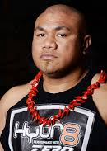
Faumuina To'aletai David Mafaufau Tua, known as David Tua, is a Samoan New Zealander probably best known as an Olympian and former professional boxer who competed from 1992 to 2013. A highly ranked heavyweight contender for most of his career, Tua was known for his formidable punching power, especially in his left hook, however he was also very active as a community leader and mentor throughout that time and continues to fulfil that role since retiring from the ring.

He has an impressive CV in community service including but not limited to, frequently speaking at school, church and community prize-givings. His David Tua Leaders Programme gives opportunities for troubled youth to share in a supportive environment. David also works at building safer communities, promoting anti-violence programmes such as White Ribbon and Ko te Kitenga Ho.

Healthy lives and healthy families are also an area that he actively supports being a board of trustees’ member on the Healthy Families Board. His gym actively supports youth who are Not in Education, Employment or Training (NEETS) by partnering with Skills NZ to offer L3 certificate in Sports and Recreation. Davis is also a Trustee on the Homai Primary School Board of Trustees. The list of active support that David gives to his communities runs to several pages and he was instrumental along with the Hon Jenny Salesa in calming the opposing factions at the recent Rugby League World Cup.

Keynote speakers

Hon Jenny Salesa
Associate Minister of Education

Jenny Salesa is of Tongan heritage and is affiliated to Lotofoa, Ha’apai; Nukualofa, Tonga and Tefisi, Vava’u. She moved to New Zealand when she was 16 to further her education. She is a graduate of the University of Auckland (BA and LLB). While there she helped found the Pasific Island Students’ Association (PILSA).
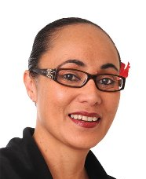

She has over 20 years’ Public Sector experience including at the Ministry of Health, the Ministry for Pacific Island Affairs and the Tertiary Education Commission.

She has been the MP for Manukau East since 2014 and is now Minister for Building and Construction, Minister of Ethnic Communities, Associate Minister of Education, Associate Minister of Health and Associate Minister of Housing and Urban Development.

She is married to the university academic Toeolesulusulu Damon Salesa. They have two young daughters.

Fa'anana Efeso Collins

Auckland City Councillor

Efeso Collins is of Samoan and Tokelauan descent. Raised in Otara by immigrant parents, he is the youngest of six children and the first to get a university education. Efeso is married to Fia, they have a young daughter, and attend a local Samoan church is west Auckland. He holds the Samoan alii matai title of Fa’anana from the village of Satufia, Satupaitea, Savaii.
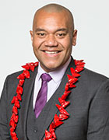

Since 2014 he has been the Auckland City Councillor for the Manukau ward.

Efeso is passionate about Pasifika people having a voice in New Zealand and has worked with young people for many years.

Vito Nonumalo
Emerge Aotearoa
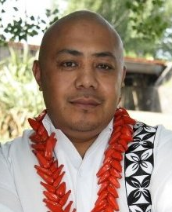
Trained originally as a journalist and broadcaster, Vito Nonumalo joined the Like Minds, Like Mine campaign in 1998 as an advisor and communications consultant. Since then, he has held a number of roles throughout mental health, these include Funding Portfolio Manager for Mental Health & Addictions at Capital & Coast and Canterbury DHBs, General Manager for Pacific Community Health Inc and as a Project Manager and Researcher for Te Pou/Le Va.

During his time at Le Va, Vito was responsible for the development of the Real Skills Plus Seitapu Pasifika Cultural Competencies which led to the establishment of Le Va’s Engaging Pasifika training.

Vito’s most apt qualification however is his own experience of mental distress and use of services as a young Pasifika person in his early teens through to his 20s, a story that is in part featured on the Depression.org.nz website.

Vito is a New Zealand born Samoan and is affiliated to Solosolo, Upolu and Fasito’outa, Upolu. He was schooled and raised in Wellington and currently lives in Christchurch with his wife and family.

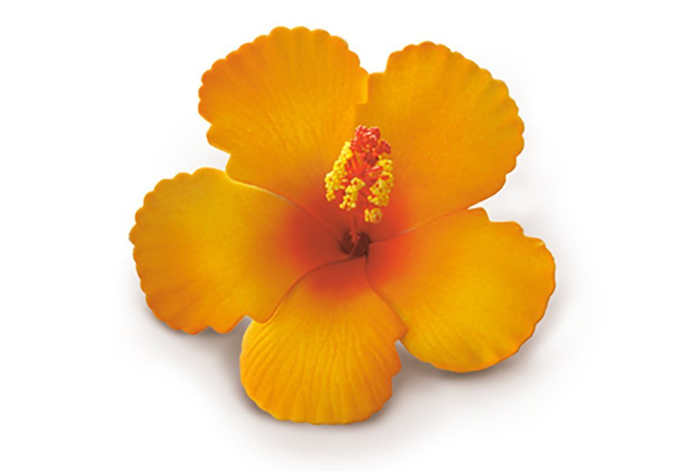

Komiti Pasifika 2018

Natalie Faitala (Area 1 / Chairperson / Executive)
Wesley College, PO Box 58, Pukekohe 2340
School ph: 09 237 0224
Email: natalie.faitala@gmail.com

Alvin Chand (Area 1)
James Cook High School, PO Box 75647, Manurewa
School ph: 09 268 3950
Email: alvinchand54@gmail.com

John Pesefea (Area 1)
Rotorua Boys’ High School, PO Box 10148, Rotorua Mail Centre, Rotorua
School ph: 07 348 6169
Email: jpesefea@rbhs.school.nz

Sinapi Taeao (Area 2)
Sacred Heart College, 65 Laings Road, Lower Hutt
School ph: 04 566 1089
Email: taeaos@sacredheartcollege.school.nz

Tai Tarai (Area 1)
Tokoroa High School, Private Bag, Tokoroa
School ph: 07 886 6109
Email: teokotait@tokoroahigh.school.nz

Sione Tauveli (Area 2)
Makoura College, PO Box 465, Masterton
School ph: 06 378 6074
Email: sione.tauveli@mc.school.nz

Andrew Barron (PPTA Field Officer)
PPTA Field Office, PO Box 52 006, Auckland 1150
Ph: 09 815 8610
Email: abarron@ppta.org.nz

Doug Clark (PPTA Afvdvisory Officer / Komiti Secretary)
PPTA National Office, PO Box 2119, Wellington 6140
Ph: 04 913 4229
Email: dclark@ppta.org.nz

Fono Dinner
Monday 16 July, 6.30pm

Inailau Dance Group
Tatau Dance Group
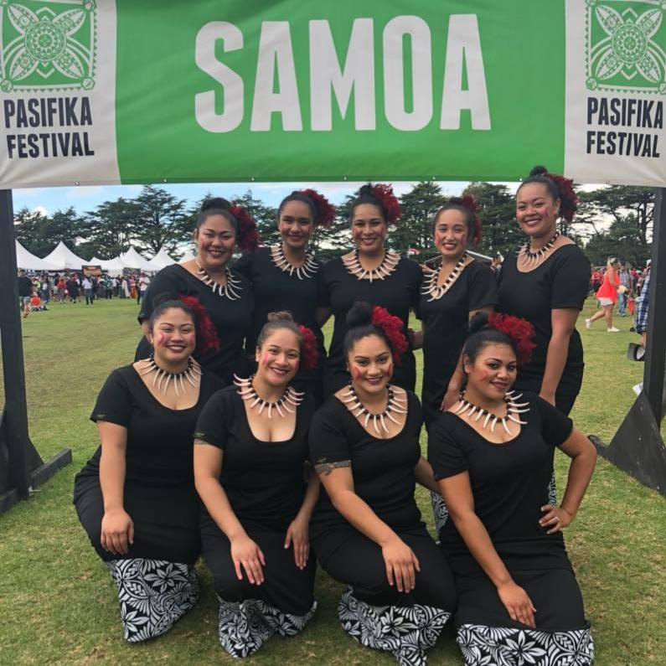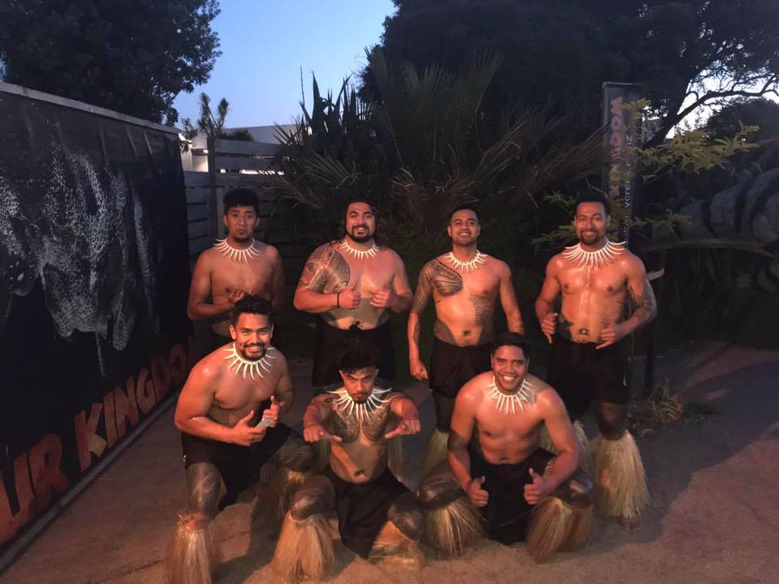

Live band: 20/20

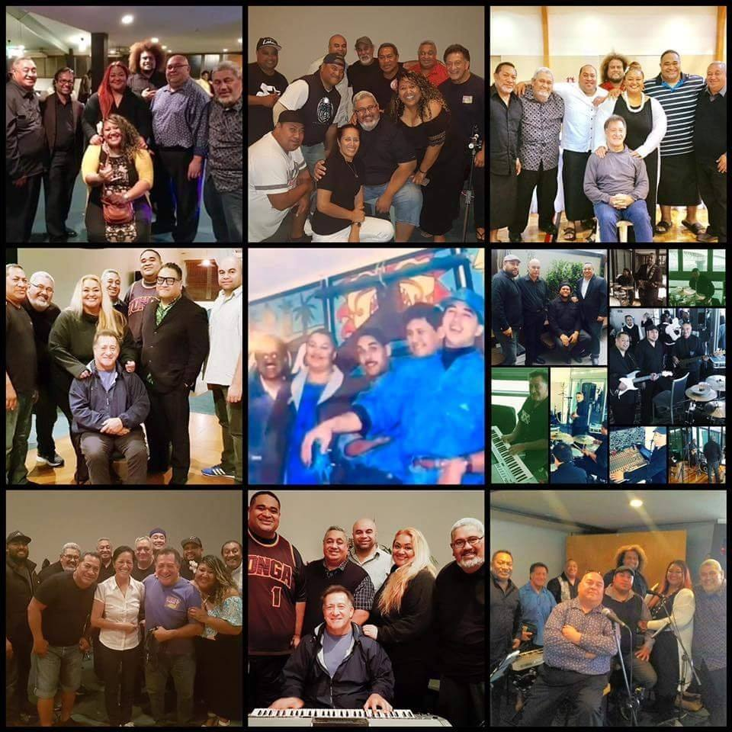
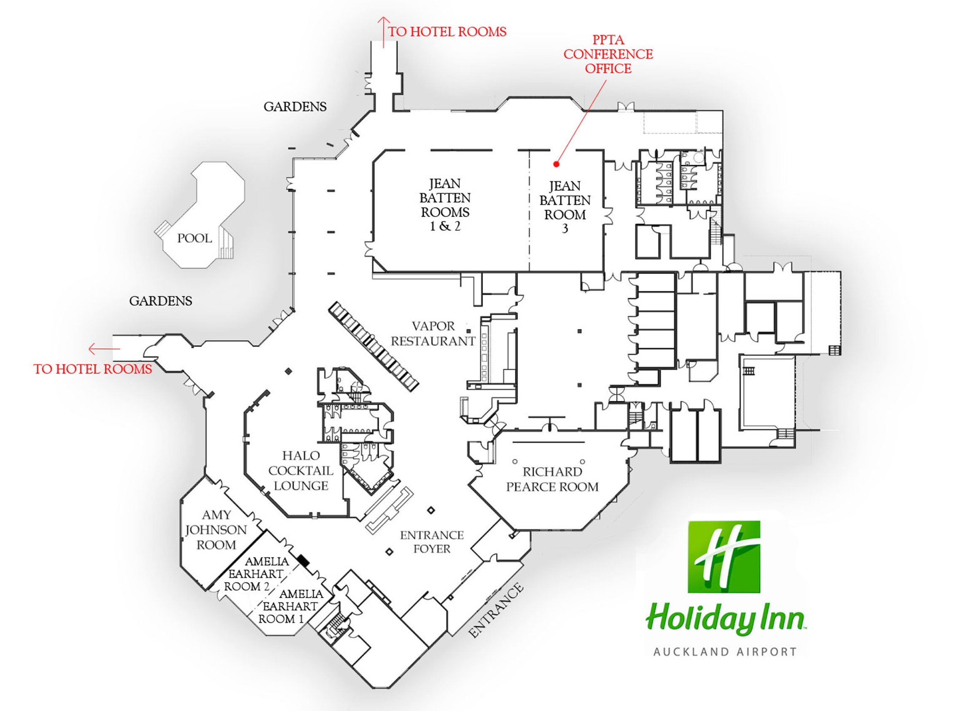
RICHARD PEARSE ROOM

